Mighty Ducks Work Log

# Team Members & Roles

* Mike Ratcliffe - Project Management, Programming/Scripting, Creative Design.
* Eddie Waite - Programming/Scripting, Audio Design, 3D Modeller
* Pearce Jennings - User Research, Narrative Design, Creative Design
* Connor Davey - Audio Design, Concept Artist, Environment Artist
* Harry Sollis - 3D Modeller, Visual Design, Environment Artist

Gantt Chart – Pre January

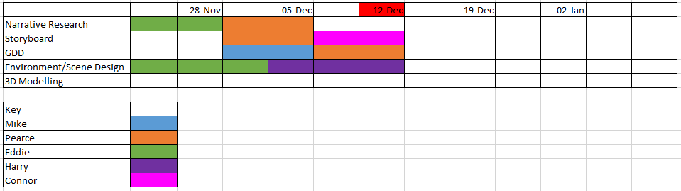

# 8th January - Trinity Centre Visit

* Went to Trinity Centre to meet Edson Burton, the Trinity Engagement and Heritage Officer

learnt about some of the history of the centre and what artists and genres were played there

* Received book about the centre "Culture and Change in Urban Bristol'
* 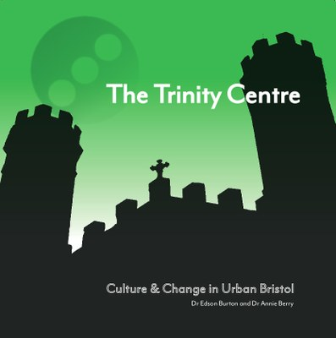
* Took photos of the centre for reference in order to 3D model the venue

6th February - Weekly Update

# Progress since Last Week:

* Eddie: Made particle system that matches the beat of the music
  + https://github.com/allanpichardo/Unity-Beat-Detection
* Integrated Lightweight Render Pipeline to Unity to allow
* Created Speaker Model

# What we did in the meeting:

* Discussed getting reference photos
* Discussed modelling Cosies - waiting on reference images
* Focus on Hip-Hop (not trip-hop, will get groans)
* Arranged meeting with Delroy Hibbert
* He will point us towards people to talk too
* Might get an interview
* Prepare Questions
* Discussed how notice board menu will work - Harry and Eddie
* Focus on specific fliers, zooms towards face to read
* When selected, zooms into photo to start scene
* Settings menu, etc.
* Discussed what will be going on in venue
  + Things going on, on stage
  + Bar, people walking to and from the bar
  + Different dances for different venues
  + Lights (lasers in Lakota)
  + Particles (smoke, etc.)

# To do:

* Take reference photos of Cosies and make a start in modelling - Mike and Pearce
* Go to Lakota and get reference photos etc. - Mike and ?
* Improve Trinity Model - Eddie
* Meet with Del, hopefully get some good feedback (maybe even an interview) - Mike and Pearce
* Find more people to talk too - Ongoing
* Chat with people at the Fleece - Pearce
* Find specific tracks/artists (maybe get in contact with the artists) - Mike and Pearce
* Carry on working on notice board - Harry
  + cut out squares to put scene images in)
* Maybe a credits scene
* Implement 3D audio, sound coming from speakers
* Get more dancing animations more suitable to music genre)
* Implement lighting - Eddie
* Implement Particle effects (smoke, etc.) - Connor
* Model decks, animate DJ - Connor

13th February

# Progress since Last Week:

* Arranged a date to meet Delroy Hibbert
* made a list of Questions to be asked
* Arranged a date to go to Cosies and The Fleece
* Model it in Maya
* Seeing if any staff have insight into Bristols music scene, any links?
* Take Photos of The Fleece
* Model it in Maya
* See if they also have any insights
* Arrange a date to go to Lakota
* Hopefully get permission to take photos of the venue
* Model it in Maya
* See if they also have insights
* Get music and tracks for specific genres, venues and eras

20th February

# Progress since Last Week:

* Visited The Fleece and took photos for reference
* Scene transitions have been set up
* Provided Delroy Hibbert with documentation link
* Requested meeting with Lakota, for insight into the club and its history and to get photos to reference for modelling

What we did in the meeting:

* Discussed Motion Capture for dances
* iPi Soft & Microsoft Kinect
* Talked about scene transitions
* Exit to menu using door, then select venue
* Transition from venue to venue, using a flyer or leaflets on a board
* Making a OneDrive to keep Delroy Hibbert and ourselves updated and on the same page

27th February

# Progress Since Last Week:

* Modelled a number of different instruments.
* Found dancing and instrument playing animations, and looked into how they can be combined together using Unity's animator.

# To Do:

* Go to Lakota, speak to the manager and get reference photos for modelling the venue - Mike and Pearce
* Go to idle hands and speak to the manager, hopefully get an interview - Mike and Pearce
* Go to Malcolm X center to get reference photos - Mike and Pearce

5th March

# Progress since Last Week:

* Rendered a bunch of dancing animations in scene
* Created a spotlight for the Trinity Centre
* Created a menu scene to transition to a specific venue

# To Do:

* Get music together for each venue, preferably from artists that have previously played there in the past - Mike
* Model The Fleece - Pearce and Eddie
* Take Photos of and get interview from people at Lakota and visit Idle Hands to hopefully get an interview - Mike and Pearce
* Visit Malcolm X to take reference photos - Mike and Pearce
* Get Demo ready for 12th March - Team

10th March

Progress since Last Week:

* Found a preliminary selection of songs to use for the venues
* LAKOTA = Roni Size - Brown Paper Bag
* TRINITY = Smith & Mighty - Walk On
* MALCOLM X = Black Roots - Ghetto Feel
* THE FLEECE = XCERTS - Fight Back
* Good progress has been made on the Demo for the 12th

11th March

# Progress since last week:

* Very productive meeting with Marti from Lakota
* ** Marti provided lots of stories to use for the scene, such as how Lakota opened and the opening night, as well as how they avoided being bought out in 97. Lots of primary information about how the music scene changed from the perspective of someone booking talent to play in the city. She also offered to put us in touch with some artists and said we can go in and take photos
* Organised facetime with Dev from Idles - will interview tomorrow (12th)

# Todo:

* Follow up interviews from Marti and Dev

* Photo Lakota (permission is now granted)

## 18th March

* Group decided the adapt change project as so

* Due to the Corona Virus and the complications that have come along with it, we have decided to allocate certain venues a specific genre of music relating to either 80s, 90s and current Punk/Live music. Unfortunately we have had to ditch the genre of Reggae because of these complications and time constraint

** Therefore we have decided adjust the scope of the project to allocate:

* House - LAKOTA

* DnB - TRINITY

* Punk/Live - THE FLEECE

* We have decided to switch out from using Particle Effects/Emitters and have now decide to use Shaders instead because of

hardware limitations and the frame rate was taking a beating as a result. Shaders allow us to change colours and add

transparency to character model.

* The light map swapper turned out to be more difficult to implement however progress has been made to allow light maps to

be changed at run-time.

# To Do:

* Get photos of Lakota ASAP - Corona difficulties

## 26th March

* Created props like glasses and glass bottles to add to the scenes

* Venue song changes :

* LAKOTA = Way Out West - Dancehall Tornado

* TRINITY = Roni Size - Brown Paper Bag

* THE FLEECE = Idols - Danny Nedelko